JUnit 5
Agenda:

- What is a unit test ?
A unit test is a small piece of code that calls your code and checks if the answer is that you expected.
Analogy – You bake a cake recipe before selling it you taste and check sweet enough? Is it baked enough? A unit test is that taste check done by the computer in milliseconds every time you check the recipe.
Without test you manually check the program every time to see whether it works correctly.
With test you press one button and know whether everything still works.
J unit 5 is a library that gives you the tool that gives you the tools and run those checks.
Every step follows the same 3 steps: Arrange, Act, Assert
- Arrange is to set things up. (Example: - Calculator calc = new Calculator () ;)
- Act is to do those things. (Example: - int result=calc.add (2,3) ;)
- Assert is checking the answer. (Example: - assert Equals (5, result) ;)

- What is Maven?
Maven is a project management and a built tool it does 3 jobs for you that are downloads libraries
(J unit), it compiles code for you, run your test with 1 command.
Analogy – Imagine you are chef (You write the recipe = java code).
Maven is your kitchen manager. You hand over a shopping list (pom.xml). The manager buys it and sets up the kitchen, cooks and tells you if the dish failed the test check.
- mvn -v : checks if maven and java are already installed.
- Mvn compile : It compiles everything.
- mvn test : compiles everything and runs all the tests present in the folder.
- mvn clean test : Deletes the old target folders first and then tests.

-Steps for j unit testing:
- Design - Understand the problem statement and write the pseudocode.
- Write code
- Write tests
- Run the tests

-Architecture of Maven
The engine room. Starts tests, talks to Ides and Maven, define how test engines plugins.
It is used by vscode, IntelliJ, maven surefire.
J unit Jupyter- The new programming model: @Test, @BeforeEach, assertions. Also contains the engine that runs Jupiter tests. It is used by the developer while writing the test.
Vintage Api- A compatibility engine that runs code J unit 3 and 4 test on the new platform. It is used by old projects that haven’t yet migrated.

Analogy: A cinema: The platform J unit is a building, projector system and the ticket counter. It can show you any movie. Jupyter is the today’s modern movie the only one you can write. Vintage is an old movie that runs on same projector. The building doesn’t care what movie plays as long as the matching engine (player) exist.

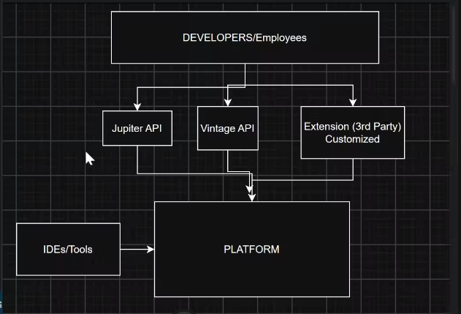

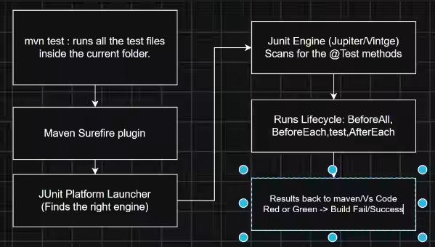

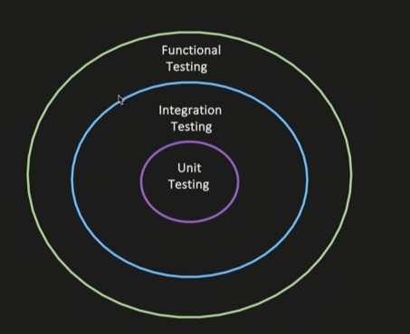

Types of Testing:
- Unit testing: Testing of an individual unit or a method.
- Integration testing: Testing of multiple modules or components together, to test if system behaves properly when wired together (the goal is not to test end to end user behavior, it is just if multiple modules or system wired together, does intended behavior).
- Usecase1: Service -> repository -> database
Wired multiple modules of one component.
- You invoke a method in the service layer.
- Verify that dependency injection works correctly.
- The flow should reach the database layer.
- Your test can assert the data was persistent into the db.
- Service A -> publish to Kafka
Validate that the message is successfully published to the Kafka topic.
- Functional testing: End to End testing of a feature or a business functionality, verifying if it works as expected.

